**Birla Institute of Technology & Science, Pilani**

**Work-Integrated Learning Programmes Division**

**Second Semester 2014-2015**

**Comprehensive Examination (EC-3 Regular)**

Course No. : SS ZG527

Course Title : CLOUD COMPUTING

Nature of Exam : Open Book

No. of Pages = 2

# No. of Questions = 7

Weightage : 50%

Duration : 3 Hours

Date of Exam : 19/04/2015 (FN)

Note:

1. Please follow all the *Instructions to Candidates* given on the cover page of the answer book.
2. All parts of a question should be answered consecutively. Each answer should start from a fresh page.
3. Assumptions made if any, should be stated clearly at the beginning of your answer.
4. Do you agree or disagree with the following potential benefits of cloud computing for end users? Provide proper justification for your agreement. [8]
5. Lower computer costs
6. Improved performance
7. Reduced software costs
8. Instant software updates
9. Unlimited storage capacity
10. Increased data reliability
11. Universal document access
12. Device independence
13. Application lifecycle has to go through multiple phases on the Managed Service Provider Cloud platform. Suggest follow up actions for the below situations during the various phases of SLA management of applications. [5]
14. Possible SLA's are identified for the application
15. SLA violation by the service provider
16. In a multi-tenant system, many tenants share the same storage or database. Assume that your cloud application uses database storage system for sharing data among multiple users. If you are advised to build a multi-tenant application that stores data of faculties of different departments of a university like BITS, suggest a database design using “dedicated table” and “shared table” methods. You can assume three department names like CSE, EEE, and ECE. For each department faculty, you need to store faculty id, faculty name, and research area. Since, it is likely that various departments (tenants) may store different data in their database tables, it is important for the cloud infrastructure to support customization of the stored data. Does the proposed design require customization? If so, what are the different customization approaches possible? Provide feasible approach you would like to suggest for the above design. [10]
17. Provide your expertise views on the following
18. Risks related to Cloud computing
19. Cloud computing in the future [5]
20. An organization debating whether to install a private cloud or to use a public cloud (e.g., the AWS) for its computational and storage needs, asks your advice. What information will you require to come to your recommendation, and how will you use each one of the following items: [6]

(a) the description of the algorithms and the type of the applications the organization will run; (b) the system software used by these applications;

(c) the resources needed by each application;

(d) the size of the user population;

(e) the relative experience of the user population; and

(f) the costs involved

***SS ZG527 (EC-3 Regular) Second Semester 2014-2015 Page 2***

1. The below diagram shows a 4 node storage solution using a Distributed File System with data protection using replication factor of 2. Answer the following.
2. In case of a node failure (Node 1), how would you distribute the data of failure node to remaining nodes (Node 2, Node 3 and Node 4)? Your data distribution should allow enough redundancy for data security and parallel I/O.
3. What was the impact on each node (Node 2, Node 3 and Node 4), while distributing failure node data? Fill in the table below. [10]

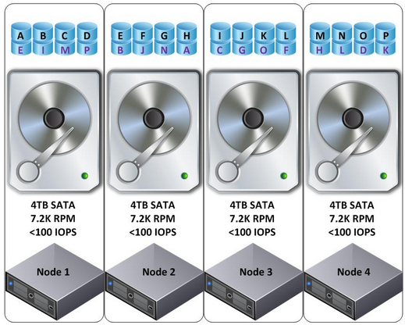

|  |  |  |  |  |  |
| --- | --- | --- | --- | --- | --- |
| **Node 2** | | **Node 3** | | **Node 4** | |
| Read I/O | Write I/O | Read I/O | Write I/O | Read I/O | Write I/O |
|  |  |  |  |  |  |

1. What are the roles of following components (services) in OpenStack cloud computing operating system? [6]
2. Nova
3. Glance
4. Keystone
5. Neutron

***********